Prue Stevenson – Artist – CV & Bio:  Fine Artist, Autism Self-Advocate, 3rd DAN Taekwondo Blackbelt and Lead Singer of “Ice Cream in a Mug” | 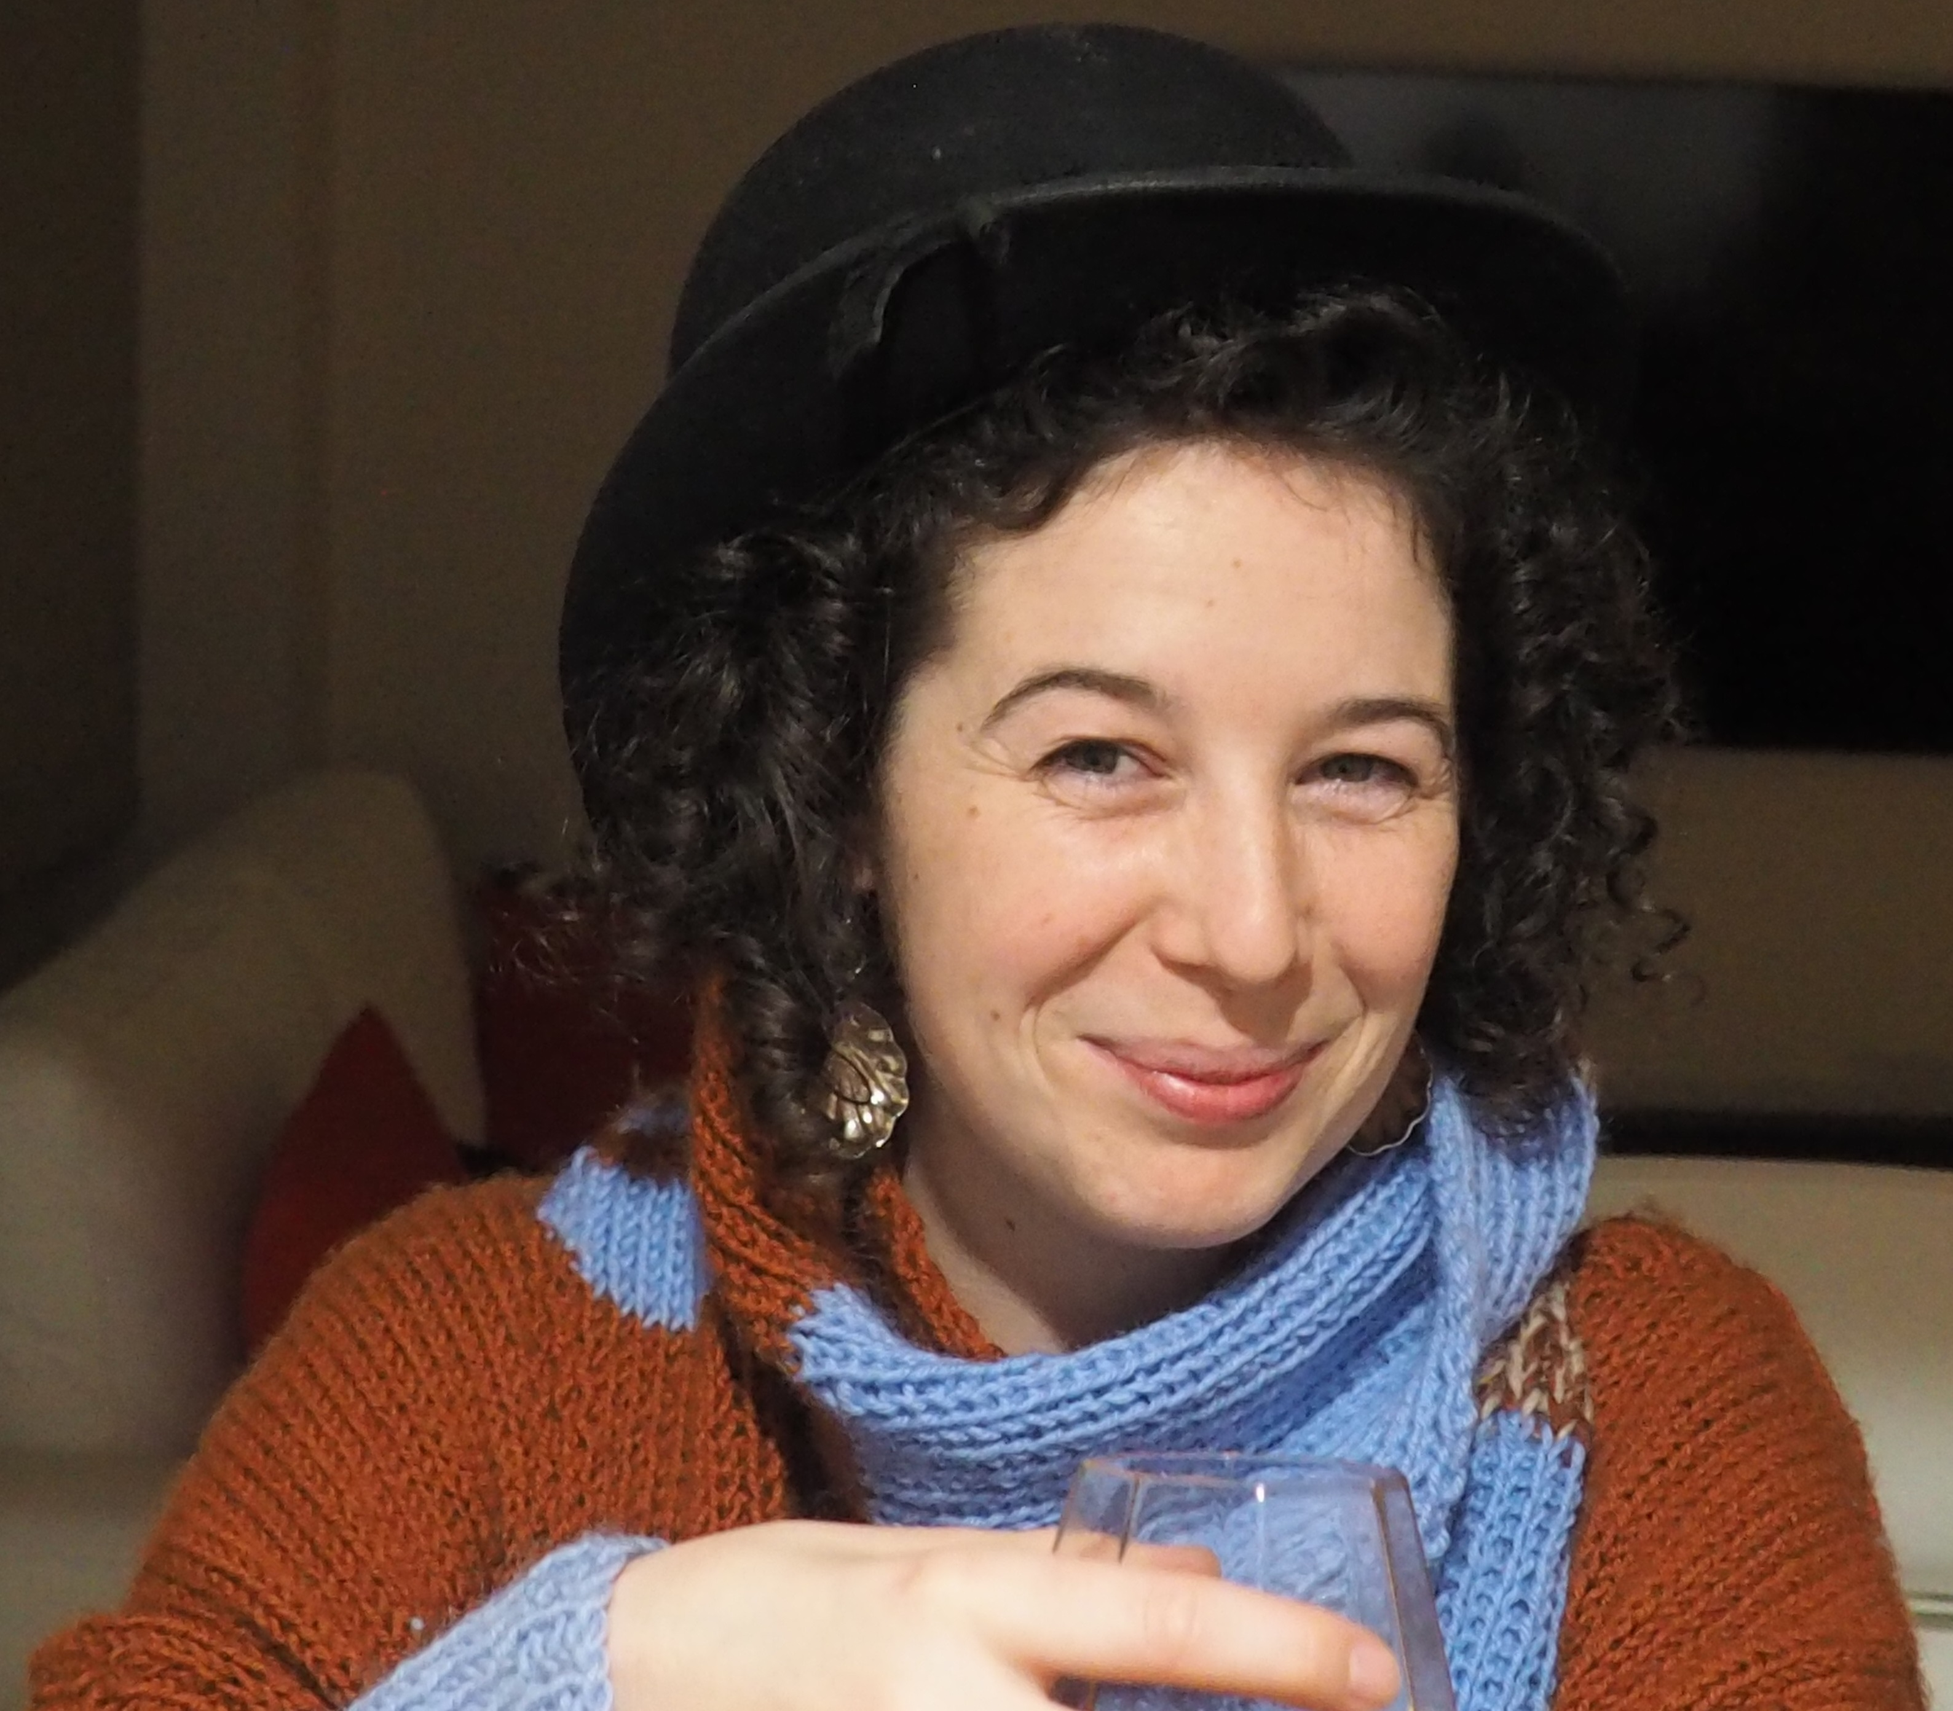
Bio
Prue is a practicing fine artist, having completed both her Bachelor of Fine Art (Expanded Studio Practice) and Master of Fine Art (by Practice) at RMIT. She is an autistic consultant with AMAZE and an ensemble member of Rawcus inclusive theatre group.

Her art practice celebrates autistic culture through textiles, sculpture, installation, performance and sensory pleasure from a neuroperspective.

She explores autistic pleasures, necessities and culture and uses repetitive and tactile processes to allow for experiences of sensory play to create spaces and opportunities for downtime.

Prue advocates for the identity, empowerment and sensory awareness of the autistic community, intersecting and colliding against the context of preconditioned stigmas and resultant systematic oppression.

She aims to celebrate and progress autistic culture for autistics, while creating experiences that are more broadly accessible.

Webpages
Webpage – “Prue Stevenson” – Bio / CV / Media / Artwork / Contact (http://www.pruestevenson.com/)
Masters ADR - "Neuroperspective"
Instagram – https://www.instagram.com/prue_stevenson/
Museum of Contemporary Art (MCA) Australia – “Don’t fear the Meltdown” Article and Artist Talk
Heide Museum of Modern Art – Professional Development: Mirka Mora & Prue Stevenson
“Stim Your Heart Out” Project – www.stimyourheartout.com (Email: stimyourheartout@gmail.com)
“Perspective Shift” SBS On Demand TV Series - "Perspective Shift"
“Do Your Thing” Women with Disabilities Victoria video series - https://www.youtube.com/watch?v=Z7qvCOo2GlI
YouTube – Spectrospective 2018 , Don’t Fear the Meltdown 2018 , Spectrospective 2017 and 2016
Facebook – Prue Stevenson Âû – https://www.facebook.com/Prue.Nosnevets
Theatre Page - Rawcus Theatre - http://rawcus.org.au/people/prue-stevenson/
“Ice Cream in a Mug” Band – Website: http://www.icecreaminamug.com/
Autism Consultant for Amaze - Amaze Training and NGV Training Example

Art Education & Tours
2017/19 Master of Arts (Fine Art) (by Practice) (MC266) with Distinction – RMIT, Melbourne, VIC.
2018 Melbourne Theatre Company (MTC), Curious Incident Design Academy – Set Design, MTC Melb, VIC.
2015 Bachelor of Arts (Fine Art) (Expanded Studio Practice) (BP201ES) with Distinction – RMIT, Melbourne, VIC.
2011 Venice Biennale Accompanied Art Tour – Latrobe College of Art, Melbourne, VIC.
2011 Diploma in Visual Arts – Latrobe College of Art & Design, Melbourne, VIC.
2008 New York Accompanied Art Tour - Latrobe College of Art, Melbourne, VIC.
2008 Diploma in Fine Arts – Latrobe College of Art & Design, Melbourne, VIC.

Exhibitions, Artist Talks, Competitions & Awards

2020 “Adaptation” Exhibition at Casula Powerhouse Art Centre, with “Expend – MCA” “Expend – MCA” and Films ("Expend - OTARC (LAI)", March 2020.
2020 Guest Speaker launching Dylan Alcott’s “ListenABLE” podcast: "ListenABLE" - Prue Stevenson March 2020.
2019 Finalist in the Moreland Summer Show 2019: Language & Liberty, Noel Counihan Commemorative Art Award , with “Your Neurotype is Valid” , Dec 2019.
2019 Exhibited the sculpture “Assistance Dogs” at the “AXIOM – A Reimagined Reality” exhibition , Dec 2019.
2019 Guest speaker for Amaze with ANZ Bank for their IDPWD “Abilities” Forum with Dylan Alcott:, Dec 2019.
2019 Selected for RMIT Post Grad Info Session Banner with “Neural Branching” , INTERSECT LIGHTSCAPES with “Process this in Your Own Time” & Awarded a Masters Course Prize for course contribution , Dec 2019.
2019 “Do Your Thing” video launched by WWDV: "Do Your Thing"- Prue Stevenson , Nov 2019.
2019 “Perspective Shift” SBS OnDemand TV Series, by Attitude Foundation & Taste Creative Nov ‘19.
2019 Presented “Syndrome Rebel” at BoK2019, including an Introduction , Live Performance and Q&A , Jun 19.
2019 Guest Artist at Heide Museum of Modern Art for Professional Development: Mirka Mora & Prue Stevenson March 2019.
2019 Guest Artist for Lara Merrett - MCA - Jackson Bella Room, with “Syndrome Rebel” and “Autism isn’t a disability, it’s a Culture” at MCA Artbar February 2019 .
18/19 Rawcus Theatre’s “Song for a Weary Throat” – Debut at the Melbourne International Arts Festival. (View Vimeo Film Trailer: https://vimeo.com/255343163). 2018 Green Room Award for Ensemble – Independent Theatre (https://www.greenroom.org.au/nominees2018/). 2019 Helpmann Award Nomination (Rawcus at the Helpmanns).
2018 Opening Speaker for MCA Australia, in partnership with the Sydney Opera House, for their Engaging Students with Disability (ESWD) forum in September 2018. Incorporating a “Live” performance “Expend” and assoc. Q&A. (Refer: ESWD2018 Forum and "Expend - MCA" and Artist Talk)
2018 Presented the “Stim Your Heart Out” Project at Autism in Education 2018 (Refer: Audio & PowerPoint Film at: "Stim Your Heart Out" Project Presentation & Artist Talk).
2018 “Stim Your Heart Out” Film, workshopped in Feb ’18 for release during Autism Awareness Month in April 2018 (Supported by the $5,000 Lesley Hall Art Grant, it is an experimental movement scores development, integrating organic forms of stimming, interlaced with interviews and conversations about the reclaiming of autism culture and language, and making stimming socially acceptable) (www.stimyourheartout.com). >26,000 Facebook Views combined at: Aspect Facebook and Amaze Facebook. And >120,000 associated Facebook Views for the http://www.onethingforautism.com.au/ campaign at Amaze Facebook Posts: Channel 9 News and Channel 10 News.
2017 Formal Theatre Performance debut, with Rawcus Theatre’s “Song for a Weary Throat” – 30/11/17 (Refer – The Age article: Rawcus theatre group explores the Question of Hope). And associated 2018 Green Room Award for Ensemble – Independent Theatre (https://www.greenroom.org.au/nominees2018/).
2017 Branding Artist with “Expend” Image, Film and Q&A Panel appearance for “The Other Film Festival: On the Spectrum” presentation at Federation Square / Melbourne Fringe Festival, with AAV / TOFF & Amaze. (Refer: https://www.melbournefringe.com.au/event/the-other-film-festival-on-the-spectrum/)
2017 “Expend” used for OTARC Annual Report 2016 – Front Cover (http://www.latrobe.edu.au/__data/assets/pdf_file/0009/812295/OTARC_Annual-Report-2016.pdf).
2017 “Expend” Artist Talk “Prue Stevenson on Art and Autism” - Latrobe Art Institute – Bendigo – Film / Audio / Presentation (http://otarc.blogs.latrobe.edu.au/expend-art-exhibition-free-bendigo-artists-talk/)
2017 Artist Talk at Autism CRC Autism Month Art Exhibition at The University of Queensland, with the Hon Jane Prentice MP , Ass. Min. for Social Services and Disability Services in attendance – (Autism CRC Facebook)
2017 “Expend” Exhibition (OTARC – Latrobe University - Bundoora - 2/04/17 to 21/05/17) – (http://www.latrobe.edu.au/news/announcements/2017/performance-art-manages-life-with-autism)
2017 “Diversibility” Discussion Paper – Prepared jointly with AAV representative Mija Gwyn, with Mija presenting the paper at AAA Meeting Place in Perth – 2/03/17. (Refer: Diversibility)
2017 Awarded the RMIT - St Vincent de Paul Grant for Students with Disabilities, for purchase of ClaroRead, a multi-sensory software which supports reading and writing, enabling the start of Masters level study (Refer: https://www.rmit.edu.au/news/all-news/2017/may/making-art-with-a-difference)
2016 Winner – Lesley Hall Scholarship – Arts Access Vic (AAV) – AAV Internship & $5,000 Art Grant for her Project - “Stim Your Heart Out” – (https://www.artsaccess.com.au/lhs-2016/).
2016 Winner - Autism CRC (Co-operative research Centre) Arts Prize – “Tunnel Vision” (https://www.facebook.com/autismcrc/posts/1789022518054005).
2016 Emerging Leader Award – Amaze – Victorian Autism Conference (VAC2016) (Amaze Facebook - Emerging Leader Award) and (Annecto News - Emerging Leader Award)
2016 Arts Activated Conference – Sydney NSW – Presenter – “Energy Transfer through my Art Practice (A new model for accessing post-grad studies for people on the autism spectrum)” (Scroll to “Track 8 Transcripts Day One” - “Access Innovations Developed by Artists”: http://aarts.net.au/artsactivated/2016-program/).
2015 “Neuroambiguous” Exhibition (including the works “Neuroambiguous”, “Expend” & “Transmuting”) - First Site Gallery – RMIT Link – Melbourne (https://www.facebook.com/events/1437863439854633/)
2015 First Prize - fortyfivedownstairs Gallery - Melbourne - Emerging Artists Award 2015 - “Without Words 1” (http://www.fortyfivedownstairs.com/events/past-events/emerging-artist-award-2015/). Currently leased to the Minister for Mental Health, Equality and Creative Industries – Minister Foley.
2014 Arts Activated Conference – Sydney NSW – Presenter - Disability-led Practice Session 4 - Creative Connections – Panel Session (http://aarts.net.au/artsactivated/gallery/day-two-presentations/)
2012 AAA (Arts Access Australia) Arts Prize – Finalist – “Point A to Point B” (http://rightnow.org.au/review-3/aaa-art-prize-for-people-with-disability/)
2011 The Undergraduate – Toyota Community Spirit Gallery – Finalist – “Life in Print” (http://www.watcharts.com.au/Undergraduate_Catalogue.pdf) (Catalogue Page 44)

Employment, Volunteer Work & Art Related Activity
2017-20 Sessional Trainer for Amaze (Ex Autism VIC) as a Lived Experience Consultant in the Amaze external training program, environmental audits and social scripts development (Organisations include MTC, ACMI, Parks Victoria, Target Australia, Legoland, Chadstone Shopping Centre, University of Melbourne: (http://www.amaze.org.au/discover/how-we-can-help-you/amaze-training/)
2017-20 Public Programs with Rawcus Theatre (e.g. Experimenta Social 18).
2018 Helped Amaze launch their “Do One Thing for Autism” campaign in May ’18 (http://www.onethingforautism.com.au/), including television interviews for Channel 9 & 10 News (Over 110,000 Facebook Views combined at: Channel 10 News and Channel 9 News).
2017 Paid consultancy role for “The Other Film Festival: On the Spectrum” presentation at Federation Square as part of the Melbourne Fringe Festival, held in conjunction with AAV / TOFF & Amaze - 27/09/17 (https://www.melbournefringe.com.au/event/the-other-film-festival-on-the-spectrum/)
2017 Paid Artist Talk at Latrobe Art Institute (LAI) Bendigo – 4/05/17 – “Art and Autism” and her “Expend” Exhibition (Need to open closed event details at: https://www.eventbrite.com.au/e/prue-stevenson-on-art-and-autism-tickets-33263868125#)
2016-20 Rawcus Theatre (Ensemble member) (http://rawcus.org.au/people/prue-stevenson/) – Current
2016 City of Melbourne External Assessment Panel Member (http://www.melbourne.vic.gov.au/about-council/governance-transparency/Pages/grants-and-sponsorships.aspx) (Section – “External assessment panel members for City of Melbourne” – Four year term from 2016).
2016 Arts Access Australia “Meeting Place” Conference – Adelaide – Attendance http://www.artsaccessaustralia.org/e-news-archive/archive/view/listid-2-aaa-enews/mailid-135-meeting-place-2016-update/tmpl-component)
2015-20 MC’d Open Stage at ConFest, including writing and performing “The Rubbish Song” (https://business.facebook.com/pg/ConfestOpenStage/about/?ref=page_internal) (Track 11: https://icecreaminamug.bandcamp.com/releases)
2015-20 Fronted Melbourne Band “Ice Cream in a Mug” (http://www.icecreaminamug.com/)
2014-18 Autism CRC Research Programs Participation (http://www.autismcrc.com.au/participate-study)
2014 OFF (Other Film Festival) Volunteer (http://otherfilmfestival.com/)
2014 Arts Access Victoria 40th Anniversary Volunteer (https://www.youtube.com/watch?v=WAn9k7TylWE)
2013 Arts Access Australia “Meeting Place” Conference – Tasmania - Attendance (http://artsaccessaustralia.org/news/483-arts-and-disability-meeting-place-what-did-you-miss)
2010-12 Annecto – David House (Referee – Joan Cooney - Mob. 0488 605 627) Voluntary and paid work providing visual arts programs for clients with disabilities.
2010-11 Victoria Manor Aged Care (Referee – Michael Greaves – Mob. 0417 325 786) Part Time placement providing portraiture experiences for the residents.

