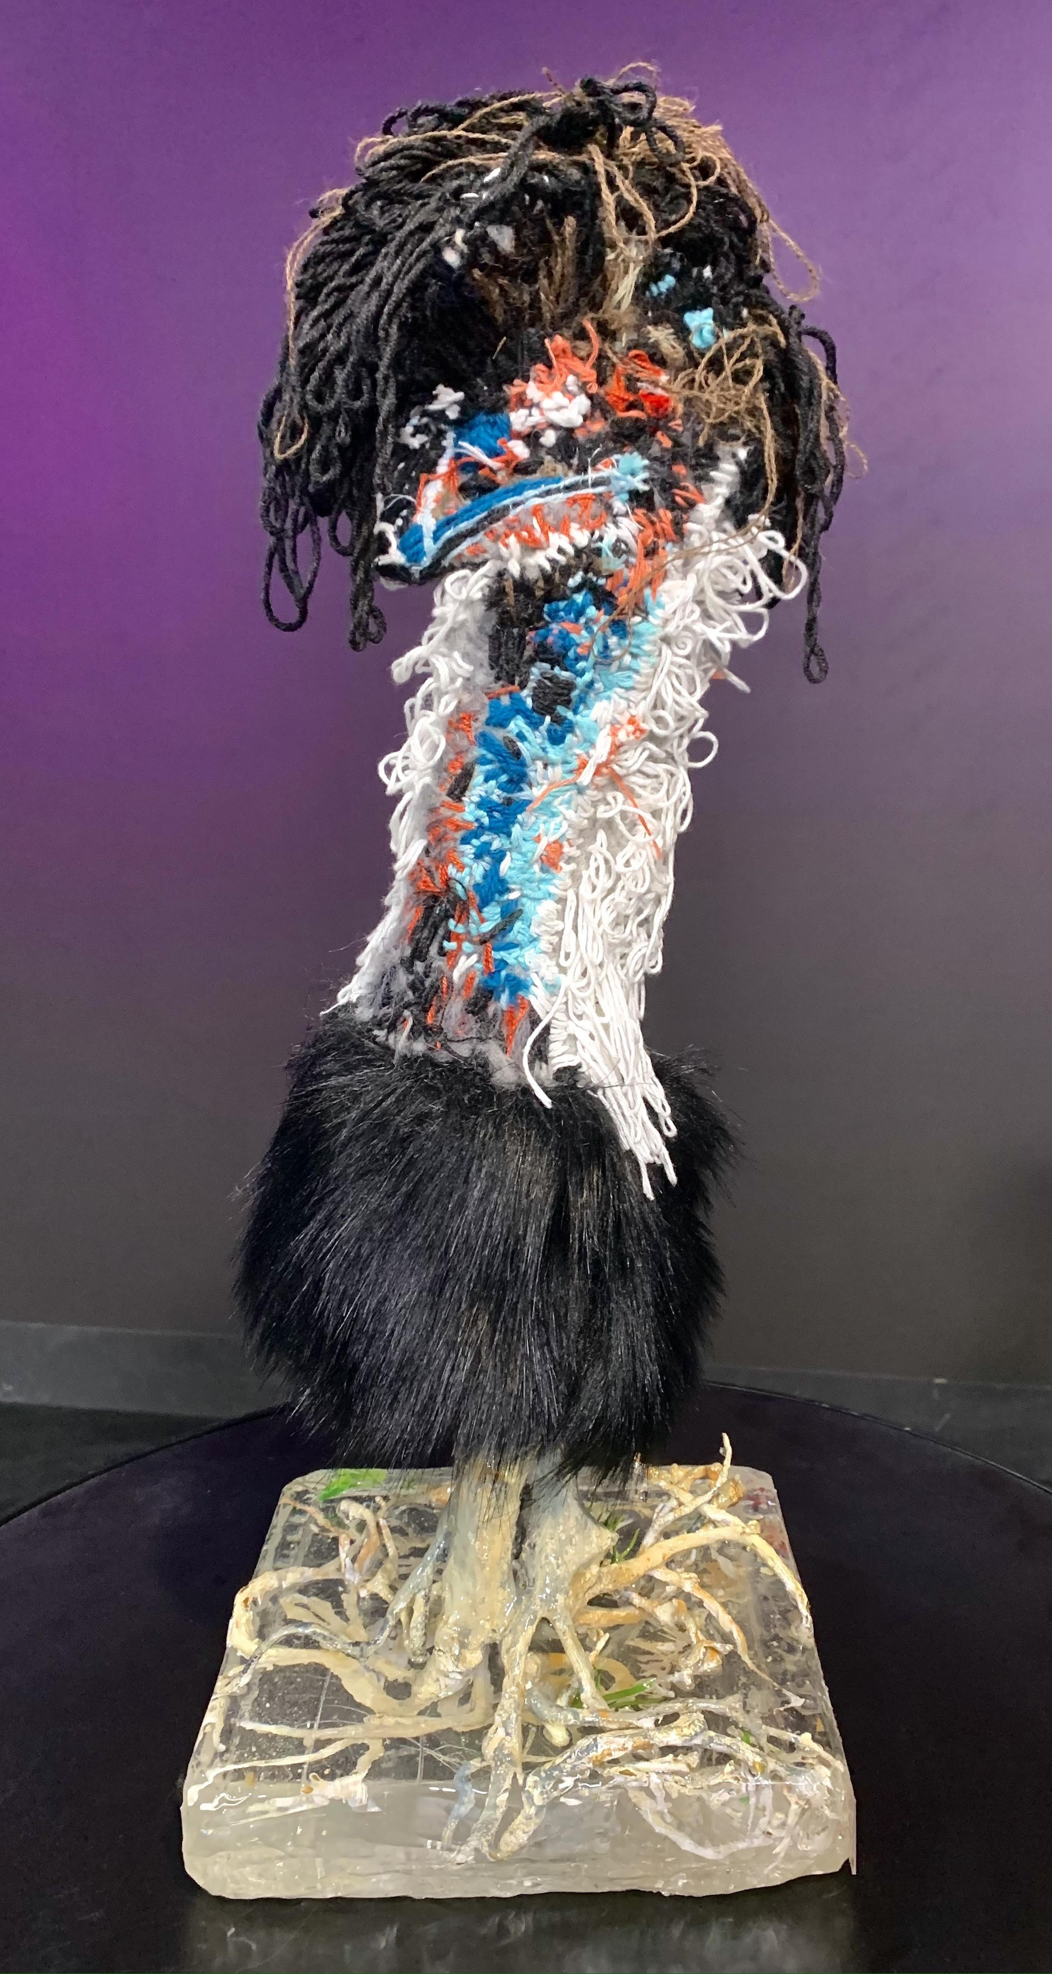

Annual Report
2020
  - (Text-only)

Arts Access Australia
Address: PO Box 3240
Robertson NSW 2577
ABN: 20 084 007 321 12
Phone: 0419 201 338
Email: info@artsaccessaustralia.org
Websites: www.artsaccessaustralia.org, www.meetingplaceforum.org
Facebook: facebook.com/artsaccessaust
Twitter: twitter.com/artsaccessaust
Instagram: instagram.com/artsaccessaust
YouTube: youtube.com/channel/UCCMGFYMOFbCDqwjMgAwr2Qw
Linked In: linkedin.com/company/arts-access-australia

©Arts Access Australia 2021

Cover image: ‘Emu’ by Daniel Kim. This textile sculpture was chosen as the award given to the 2020 National Leadership Award winner. The sculpture was highly commended in the 2018 Seed Stitch Contemporary Textile Awards, held by the Australian Design Centre. Daniel Kim is an artist at Studio A in NSW.

Acknowledgment of Country
We pay our respects to Elders past, present and emerging, and acknowledge Aboriginal and Torres Strait Islanders as the first peoples and traditional custodians of Australia – people who have sung their songs, danced their dances and told their stories on these lands for thousands of years, across many generations, and continue to do so. They have never ceded sovereignty and remain strong in their enduring connection to land and culture.

Contents
About Arts Access Australia 4
Our people 5
Our Board 5
Our staff 5
Our supporters 6
Chair’s report 7
CEO’s report 9
2020 overview 10
Providing information 11
Systemic advocacy 12
CEO Leadership Group 12
Member Survey 12
Submissions to government 13
Sector development and representation 15
Meeting Place 2020 15
Writing Place 16
National Leadership Award 16
National Arts and Disability Awards 17
Disability-Only Forum 18
Treasurer’s report 19
Thank you to our 2020 supporters 20
Major funder 20
Meeting Place Technical Partner 20
Meeting Place Media Partners 20
Support us 20
Become a Member 20
Donate 20

About Arts Access Australia
Arts Access Australia (AAA) is the national peak body for arts and disability in Australia. Our vision is for a diverse and vibrant Australian arts and culture enriched by the strong voice and contribution of people with disability. We increase equitable access and opportunities for artists, arts workers, participants and audiences with disability in Australian arts and culture. We do this through systemic advocacy, sector development and representation, and information provision.
Established in 1992, AAA is a disability-led company limited by guarantee. Our CEO and at least 50% of our board members identify as a person with disability.
AAA provides three main services:
- providing information
- systemic advocacy
- sector development and representation.
AAA adopts an inclusive approach and works across all disability types, all art forms and across all States and Territories of Australia.
AAA is a membership-based organisation. Our members include State-based arts and disability organisations, individual artists, arts workers and arts leaders with disability, and others within the broader arts and cultural sector who share our vision of full and equal opportunity for cultural participation and contribution by all Australians.
For throughout 2020, the Australian Government funded AAA through the Australia Council for the Arts. AAA is very grateful for this support, for without it, we would not have been able to operate for the benefit of our members and the wider arts and disability community in Australia.

Our people

Our Board
AAA is a disability-led organisation governed by a Board of Directors, at least 50% of whom identify as a person with disability.
In 2020, the Board Members were:
- Belinda Locke, Chairperson and Ordinary member from Victoria
- Liz Martin, Deputy Chairperson / Original Board Member from NSW
- Peter Kearney, Treasurer and Ordinary Member from NSW
- Leah Maund, Co-opted Board Member from WA
- Larissa MacFarlane, Ordinary Board Member from VIC
- Martin Sawtell, Co-opted Board Member from SA
- Satvinder Sekhon, Co-opted Board Member from WA
Outgoing Board Members:
- Carol Taylor
- Christine Johnson
- Coralie Bishop
- Guy Morgan

Our staff
AAA is run as a virtual organisation. All staff are part-time and work together to coordinate the daily running of AAA from locations across Australia.
- Matthew Hall, CEO (from June 2020)
- Bev East, Interim CEO (until July 2020)
- Harmonie Downes, Business Development Manager (until August 2020)
- Yvette Tulloch, Communications Manager (from June 2020)
- Naomi Chainey, Communications Manager – Maternity Leave Cover (until June 2020)
- Maxxi May, Program Manager
- Jo-Anne Jenkins, Finance Officer (from October 2020)
- Sarah Briggs, Finance Officer (until November 2020)

Our supporters
Our major funder
AAA’s core funding support in 2020 was received through the Australian Government through the Australia Council for the Arts, its arts funding and advisory body.
Our donors
Thank you to the following supporters who helped us to create change with generous donations in 2020.
- Feilman Foundation
- Fiona Ariva
- Lynne Frank
- Jess Olorenshaw
- Lucille Bruyand
- Timothy Phillips
Our partners and sponsors for Meeting Place 2020
AAA would like to express our sincere thanks to the National Portrait Gallery for their generous technical support for Meeting Place 2020. We would also like to thank our media partners ArtsHub and Vision Australia Radio for their assistance in promoting and documenting the forum.
Our Members
AAA is supported by our 117 members, comprised of individuals who are artists, arts workers and arts leaders with disability who are forging professional careers in the arts or making art through creative community connections, and arts and cultural and community organisations, including our Original Members – the arts and disability organisations in the States and Territories:
- Access Arts (CPL)
- Accessible Arts NSW
- Incite Arts
- Arts Access Darwin
- Arts Access Victoria
- DADAA
- Access2Arts

Chair’s report
2020 was a transformational year for AAA as we navigated significant changes to our funding, the global pandemic, and embraced new leadership of the organisation.
At the news of the loss of four-year funding from Australia Council for the Arts, we reaffirmed our continued commitment to make every effort to ensure the survival of AAA to undertake critical national advocacy, facilitation and leadership on arts and disability matters.
The Board began conversations with key government agencies to identify potential activity streams and funding options and a working party convened regularly to discuss and debate options for the way forward, inviting people long associated with AAA to join as guests to share their thoughts, views and knowledge of the organisation’s history.
We thanked Meagan Shand for the incredible impact she made on AAA with her leadership over three years as CEO; taking what we stand for, and the artists with disability we champion, from Perth to Berlin to Alice Springs to Canberra with our Meeting Place events. Meagan will be greatly missed by all at AAA, and we wish her every future success as she embarks on new horizons.
Matthew Hall was appointed as Chief Executive Officer at this pivotal point in time for the organisation, and for the arts sector as a whole. A lawyer by trade, Matthew brings to AAA 20 years of management experience across both commercial and non-profit organisations. He also has personal experience of living with disability, ensuring AAA’s continued commitment to disability leadership.
It has been a delight to work with Matthew thus far, and we look forward to an exciting era for AAA under Matthew’s guidance. We also acknowledge the contribution of Interim CEO Bev East, who provided instrumental support to the organisation for four months as we transitioned leadership.
2020 was a year of many firsts for AAA. We delivered Meeting Place online for the first time via Zoom with national and international speakers. Writing Place, edited by Gayle Kennedy, was launched as an online magazine showcasing the work of d/Deaf and disabled writers. Our first online Disability-Only Forum in late 2020 highlighted how invaluable our members’ experiences and feedback are to AAA.
We partnered with Australia Council for the Arts once again to present the National Arts and Disability Awards for 2020, this time as a live-streamed, inclusive and accessible online event. Together we recognised Australian artists and arts-workers who have made an outstanding contribution to the artistic and cultural life of the nation and proudly announced Abbie Madden as the recipient of AAA’s National Leadership Award.
On behalf of my fellow Board members, I would like to express our sincere gratitude to all of the organisations, members, and individuals whose support has allowed us to deliver a year of successful initiatives in a particularly unusual context. I would also like to thank outgoing Board members Carol Taylor, Christine Johnson, Guy Morgan and Coralie Bishop for their service to AAA.
Finally, a huge thank you to the staff of AAA, including CEO Matthew Hall, for their diligence, unwavering commitment and creative thinking that has seen us through the year. We are so very proud of you and the work you are doing.
Belinda Locke
Chairperson, Arts Access Australia

CEO’s report
I am very pleased to present my first report to AAA’s Members and other important stakeholders as Chief Executive Officer. I am also very grateful for the trust and confidence that the AAA Board have expressed in me, and my personal and professional attributes and experiences, in appointing me to the position.
I also recognise the privilege I have been given, together with the weight of the challenges we face, in leading AAA at this pivotal period that will determine AAA’s future, and strongly influence the opportunities, outcomes and quality of experiences throughout the course of the personal lives and professional careers of all our stakeholders with disability. I want to assure you that I take this responsibility very seriously, and the potential effects on AAA and our stakeholders is at the heart of everything I do in carrying out my role.
It is important that I record formally Bev East’s comprehensive and insightful handover of the role to me. The professionalism in her attitude and approach, the relevance and quality of the information included, and the generosity of her time (which continued after she left her role as interim CEO) allowed me to come up to speed quickly and hit the ground running.
2020 was certainly an interesting and challenging time to take up this role. Even though faced with significant challenges imposed by COVID-19 and funding pressures following the decision by the Australia Council for the Arts, my fantastic team and I, assisted by your Board, have continued to work to achieve a diverse and vibrant Australian arts and culture enriched by the strong voice and contribution of people with disability. We have worked hard to increase equitable access and opportunities for artists, arts workers, participants and audiences with disability, through systemic advocacy, sector development and representation, and providing information. More details of our work, and projects for 2020 are set out in later sections of this Annual Report.
I want to thank all of the team who have worked incredibly hard with me on your behalf: Yvette Tulloch, Maxxi May, Harmonie Downes, Sarah Briggs and Jo-Anne Jenkins. I also want to thank your Board for their support and, in particular, the guidance and wise counsel of AAA Chair Belinda Locke.
Onwards and upwards for 2021!
Matthew Hall
Chief Executive Officer, Arts Access Australia

2020 overview
2020 was a challenging year for AAA.
The organisation undertook a change in leadership with CEO Meagan Shand completing her contract with AAA at the beginning of 2020. Interim CEO Bev East provided invaluable support whilst the Board undertook a search for a new CEO was appointed. In June, we were delighted to appoint Matthew Hall as CEO following a nation-wide recruitment campaign. Matthew’s appointment continues AAA’s commitment to disability leadership.
During the first quarter of the year, AAA was also notified of change in funding from 2021, with the news that we were not successful in our application to the Australia Council for the Arts to renew our existing multi-year funding (and that AAA would receive reduced transitional funding for 2021. At around the same time, Australia began to experience the first of the strict public health measures in response to the COVID-19 pandemic that severely restricted business, and changed the way in which many organisations, including AAA, had to operate for the rest of the year.
Despite these challenges, AAA persevered in our work to advance equity in the arts for d/Deaf and disabled Australians through information, systemic advocacy, and sector development and representation. We reached out to our Membership to better understand their priorities and their challenges in the face of the pandemic lockdowns (pages 12-13).
We delivered our first online Meeting Place forum in September to around 150 registrants (page 15), and we worked with State organisations partners to make detailed submissions to the Royal Commission into Violence, Abuse, Neglect and Exploitation of People with Disability and the Parliamentary Inquiry into Australia's Creative and Cultural Industries and Institutions (page 13 and 14 respectively).
We co-hosted the second National Arts and Disability Awards with the Australia Council for the Arts on 3 December, the International Day of People with Disability, at which we presented our National Leadership Award for the second year running (pages 16 and 17). We finished the year hosting a fantastic discussion with our valued community at our first online Disability-Only Forum (page 18).

Providing information
In 2020, AAA provided information, advice and opportunities to our Members and the arts and disability sector more widely, through our content and media partners, key stakeholders, our social media channels, by email, and through our websites: artsaccessaustralia.org and meetingplaceforum.org.
2020 in numbers
Membership increased by 27%
Up to 41,028 people reached with information, advice or opportunities
163 direct requests for information or advice
$10,000 provided in leadership training and skills development
34 d/Deaf and disabled artists/arts-workers profiled and promoted
2 submissions to government on improving policy to support d/Deaf and disabled artists, art workers, participants and audiences

Systemic advocacy
In 2020, AAA continued to engage leaders from State-based arts access organisations through the CEO Leadership Group. AAA also reached out to its membership to gather information on experiences and priorities for our community, following the start of the global pandemic. AAA drew on the information and engagement of this community to advocate for d/Deaf and disabled people in the arts through two submissions to government.

CEO Leadership Group
AAA continues to facilitate the CEO Leadership Group, where leaders from each of the State-based arts access organisations meet to share information and insights and collaborate around key issues and advocacy.
As with many initiatives, due to COVID-19 restrictions, the CEO leadership group met only online in 2020. The submissions to the Royal Commission (page 13) and the Parliamentary Committee (page 14), as well as Meeting Place (page 15) and the National Leadership Award (page 16) were key matters for discussion and agreement throughout the year.
Many of the State-based arts access organisations represented at the CEO Leadership group meetings are the original members of Arts Access Australia.
Organisations represented at the meetings in 2020 were:
- Access Arts (QLD)
- Access2Arts (SA)
- Accessible Arts (NSW)
- Arts Access Australia (host)
- Arts Access Victoria
- Belco Arts (ACT)
- DADAA (WA)
- Darwin Community Arts (NT)
- Incite Arts (NT)

Member Survey
In April and May 2020, AAA conducted a survey of its core network. The Member Survey was designed to provide more information regarding our current membership through quantitative and qualitative data collecting. The aim was to learn more about members, their priorities, and the issues within the arts and disability community. Questions were included about the impact of COVID-19, Meeting Place 2020 programming, and AAA's strategic outlook.
Questions were aimed at individual and organisational Members and subscribers to AAA’s free mailing list. The survey was sent out on 25 April and closed in mid-May. We are very grateful for the time and effort taken by all of the 188 respondents to our survey. Their input is invaluable. Of the 188 respondents, approximately one-third were members of AAA and one-third were subscribers to our mailing list, providing a broad spectrum of experience.
The majority of respondents to demographic-identifying questions were of professional workforce age (25-64), identified as female, and were low-income earners (at least 75%), were sole traders or work part-time/casually/contracted (only 12% worked full-time), identified as a professional artist (43%) or an emerging artist (39%), and more than a quarter identified as LGBTQI – which is significantly above the national average of about 11% (Australian Human Rights Commission, Face the Facts, 2014).
Almost 1 in five respondents (78.70%) identified as having disability, ranging from physical disability (45.88%) to chronic illness (40%) to psychosocial (35.29%) to neurodiverse (20%) and others.
The Survey provided a valuable insight into our community’s experiences, thoughts and opinions in 2020. Information gleaned from the Survey was used to support recommendations in the joint submissions to the Disability Royal Commission and to the Parliamentary Inquiry into the arts (pages 13-14). Information from the Survey was also used to inform the thematic programming of Meeting Place 2020 (page 15). Information gathered in this Survey will continue to be used to inform the future work of AAA, where relevant and appropriate.

Submissions to government
AAA led joint submissions to two government-led inquiries in 2020.

Royal Commission into Violence, Abuse, Neglect and Exploitation of People with Disability
In September 2020, AAA and arts and disability peak bodies in the States and Territories submitted a joint submission to the Royal Commission into Violence, Abuse, Neglect and Exploitation of People with Disability in response to the Commission’s inquiry into employment, as it relates to artists and arts workers with disability, including key issues and examples of good practice.
The submission acknowledged the deep and systemic discrimination experienced by disabled artists, resulting in under-representation, a 42% disability pay gap, and a higher unemployment rate compared with non-disabled artists.
Our submission made a number of recommendations, including:
- a new National Disability Agreement
- dedicated funding for access in all government budgets
- set employment targets for artists with disability in all States and Territories that include targets around management and leadership and have an aim of reducing income disparity
- peer assessments of arts funding applications by people with disability to be assessed by a panel that includes a majority number of people with disability
- a review of how the NDIS can better support artists to achieve professional careers, given that the NDIS currently categorises art under therapy or recreation.
The submission also calls upon the Royal Commission to address how d/Deaf and disabled creatives who are not eligible for the NDIS will be supported to participate in the arts.
A copy of this submission is available on our website.

Parliamentary Inquiry into Australia's Creative and Cultural Industries and Institutions
In October 2020, AAA again led a process to draft a joint submission (together with many of the arts and disability peak bodies in the States and Territories) to the House of Representatives Standing Committee on Communications and the Arts: Australia’s creative and cultural industries and institutions. AAA took the opportunity to provide the Standing Committee with information and to contribute to the important discussion on how the Standing Committee should look at Australia’s creative and cultural industries and institutions, in light of the Minister’s terms of reference, in relation to artists, arts workers and audiences with disability, including key issues and examples of best practice.
The submission included a number of recommendations, including the renewal of the National Arts and Disability Strategy as a matter of priority, and the development and implementation of a National Arts, Culture and Creativity Plan to inform more coherent policy settings and investment at all levels of government.
The submission also invited the Office of the Arts, Australia Council for the Arts and NDIS to jointly resolve, endorse and implement a set of national best-practice guidelines that support a harmonised framework for the full cultural inclusion of Australian artists and arts workers with a lived experience of disability. AAA believes that it is important that these guidelines, or Principles, are made a mandatory condition for receiving government arts funding at the national and state levels, similar to the Protocols for using First Nations Cultural and Intellectual Property in the Arts. This is an issue on which AAA will continue to advocate for, and seek meaningful change, throughout 2021.
A copy of this submission is available on our website.

Sector development and representation
AAA presented several events in 2020 centred on the arts and disability sector: Meeting Place, the Disability-Only Forum, and the National Arts and Disability Awards, which was co-presented with the Australia Council for the Arts. These events, along with professional development outputs and opportunities such as the inaugural Writing Place magazine and the National Leadership Award, aimed to boost development and representation for the arts and disability sector.

Meeting Place 2020
“Congratulations to the whole team! You really pulled off a wonderful event, and so great to reach new people who might not be able to have attended otherwise. I think it's a hybrid future – not one or the other – both online and IRL!”
Meeting Place survey respondent
Meeting Place, AAA’s annual signature event, is a national disability-led forum. The forum brings artists and arts workers with disability and arts and cultural leaders together in an accessible, safe, inclusive and supported space to present, perform, discuss and debate the latest in arts and disability.
In 2020, Meeting Place was delivered entirely online for the first time in the event’s history. The forum took place on 15 and 16 September and was held via Zoom, engaging an audience of 154 registered participants. Recordings of each session, where copyright allowed, were made available after the event via the dedicated Meeting Place website: meetingplaceforum.org.
The Meeting Place 2020 program was curated around the theme ‘Creating Space’ for d/Deaf and disabled artists, whether that be space in community, online, politically or otherwise. The two-day program included a diverse mix of speakers, panel discussions, artistic showcases and interactive sessions. The program development was greatly assisted by an Advisory Committee comprising three artists with disability: Daniel Savage, Liz Martin and Jordan Fyfe.
AAA staff member Maxxi May took on the role of Project Manager for the event and technical support was provided by the National Portrait Gallery, a partnership which came about as a result of a strong working relationship providing support to the Gallery for its pilot series of accessible virtual tours. Media partners for the 2020 event were Vision Australia Radio and ArtsHub. We are very grateful for the support and assistance of each of these invaluable partners, without whom we would have struggled to present a professional, engaging and relevant event.

Writing Place
“From the beautiful, and ethereal to the practical and gut wrenching, I think we have arrived at a good overview of the consistently great writing that exists within the Disability Community right now.”
Editor, Gayle Kennedy
In 2020, the Meeting Place forum also included the launch of the inaugural edition of Writing Place.
Continuing the 2020 Meeting Place theme of ‘Creating Space’, Writing Place was produced as a way of creating a space to profile the work of Australia’s underrepresented d/Deaf and disabled writers. An open call out for contributions resulted in a competitive selection of entries in genres including short fiction, personal essays and poems.
Editor Gayle Kennedy curated the final selection, with ten exceptional writers selected for inclusion: Jamila Main, CB Mako, Anna Jacobson, Heidi Everett, Becky Van Leeuwen, Simone Busch, Daley Rangi, Kai Ash, Amy Tingay and Emily Dash. Collectively, their writings touch on personal and political aspects of taking and creating space as disabled people, experiences of life during the COVID-19 pandemic, accessibility in online environments, connection to nature, intersectional identities, speaking up and also being excluded or erased from the mainstream narrative.
Writing Place can be found at on the Meeting Place website and is available for free.

National Leadership Award
“I’m a great believer in the importance and the power of the arts at the grass roots – in local communities where everyday people interact with, engage in and benefit from the arts. I’m very interested in ensuring that I harness the many benefits that [the National Leadership Award] will bring me to become better at leading by example at that grass roots level, to create the greatest reach possible for, and normalise access for and inclusion of artists and audiences with disability”.
Abbie Madden, Recipient of the 2020 AAA National Leadership Award
The AAA National Leadership Award was established to improve employment and enterprise outcomes for new and emerging leaders with disability in the arts, emphasising the importance of disability-leadership in long-term change making. The Award provides $10,000 and other support to the recipient to develop leadership skills to realise their leadership ambitions.
In 2020, AAA was delighted and honoured to present our National Leadership Award to Abbie Madden. The Award recognised Abbie’s leadership as a dancer, performer and choreographer, and founder and artistic director of inclusive dance and circus company, Blindful.
AAA presented the Award at the National Arts and Disability Awards ceremony on 3 December, which was held in partnership with the Australia Council for the Arts.

National Arts and Disability Awards
AAA again partnered with the Australia Council for the Arts to present the National Arts and Disability Awards on International Day of People with Disability for the second year running.
The National Arts and Disability Awards recognise and celebrate the talents of Australian d/Deaf and disabled artists and arts workers, and the vibrant and critically important contribution they make to the fabric of Australian culture. The Awards recognise artists who have made an outstanding contribution to the artistic and cultural life of the nation.
The recipients of the 2020 National Arts and Disability Awards were Emily Crockford (Emerging Artist, Australia Council), Gaelle Mellis (Established Artist, Australia Council) and Abbie Madden (National Leadership Award, AAA (page 16)).
The Awards Ceremony was held entirely online with tremendous engagement and participation by our community, throughout the event. The format provided a great opportunity for people from all over the country to participate, on an equal footing, and with equal access. There was very strong support for the separate (YouTube) feed for audio description and the “picture in picture” Auslan interpretation. Anecdotally, the audience felt they were a real and important part of the event, and that it was an event that was designed for them, at home, rather than an event designed for an ‘in-person’ audience and the ability of remote or online attendance as an after-thought.
The numbers of attendees were very stable throughout the event broadcast with:
- 1300 viewers live in Facebook (and a further 200+ views subsequent to the broadcast)
- 272 viewers on the YouTube audio described channel
- 70 viewers using the EventCast app
- 152 viewers through the EventCast website
The event was produced by FourthWall productions and was streamed via the EventCast app and web platform, Facebook and YouTube.
The recording of this event is available on-demand, so you can join in celebration of the award recipients, including performances by leading Deaf poet Walter Kadiki and the Liz Martin Trio.
Audio-described feed via the AAA YouTube Channel.
Auslan-interpreted and captioned feed via Australia Council for the Arts’ Facebook page.
AAA looks forward to continuing to work closely with our partner, the Australia Council for the Arts, in presenting the National Arts and Disability Awards in 2021.

Disability-Only Forum
AAA hosted our first online Disability-Only Forum on 9 December 2020. The Forum was designed as a safe, accessible space for d/Deaf and disabled people in the Australian arts community to network and discuss issues pertinent to them.
The Forum was a rewarding experience where we all learned together about networking in the online space. We were delighted and grateful as everyone threw themselves fully into the experience, sharing openly and creating genuine connections within the group.
The Forum also provided a space to discuss topics top of mind for participants. These discussions highlighted AAA’s important and continuing role to play in fighting for an elevated presence of the arts and disability sector.
Our community emphasised that AAA must remain conscious for whom we are speaking, and ensure that we speak for all, including artists and arts workers who are d/Deaf or with disability who are culturally and linguistically diverse, LGBTQIA+ or Indigenous.
Our community also expressed the continued need for AAA to fight for greater inclusion and better access, especially as the world adapts to COVID-19, and that the gains that have been made in areas such as online access and inclusion are not lost.
AAA would like to extend a huge thanks to Paul Calcott, from First People’s Disability Network, for providing a welcoming and beautiful Acknowledgement of Country, and to all of our volunteer facilitators: Kath Duncan, Madeleine Little, Martin Sawtell, Penny Pollard, Hanna Cormick and Belinda Locke.

Treasurer’s report
2020 was a challenging year for everyone and Arts Access Australia was not immune. Our major event, Meeting Place, was moved to an online format. Despite this, ticket sales income in 2020 was the highest we have had, by a significant margin, making a substantial contribution to the event costs. Although the costs associated with running the event outweighed the tickets sales by $10,125, AAA made a significant contribution to cover the difference because the Board considers the event to be very important for the arts and disability community, and an essential part of delivering on the AAA mission.
Our total revenue in 2020 was $344,100 [2019: $332,900]. This was, in part, thanks to the $81,838 received in subsidies from the Federal Government to carry us through the Covid pandemic. While donations, individual and corporate, fell in 2020 to $2,992 [2019: $24,750], memberships increased to $6,990 [2019: $5,243].
Our overall expenditure fell in 2020 to $277,450 [2019: $382,641]. The most significant area of savings occurred due to the Meeting Place event not going ahead face-to-face which resulted in an underspend of $76,030. Second to this was a reduction in staffing and administration costs by $29,161.
2020 saw a significant improvement to our net result, a profit of $66,650 [2019: ($49,741)]. This was a welcome contribution to the positive financial position of AAA as we move out of the pandemic and into 2021.
Peter Kearney
Treasurer, Arts Access Australia
The financial report for the company for the financial year ending 31 December 2020, including the audited financial statements, notes accompanying the statements, auditor’s independence declaration and independent auditor’s report is available separately as a PDF on the AAA website.

Thank you to our 2020 supporters

Major funder
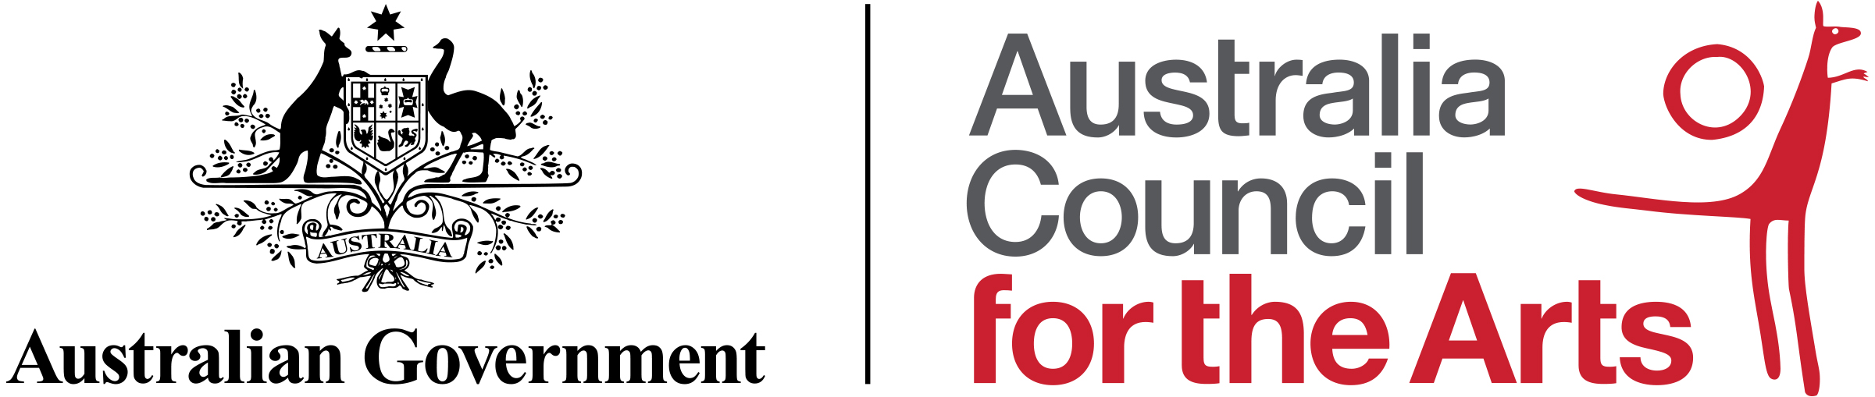

Meeting Place Technical Partner
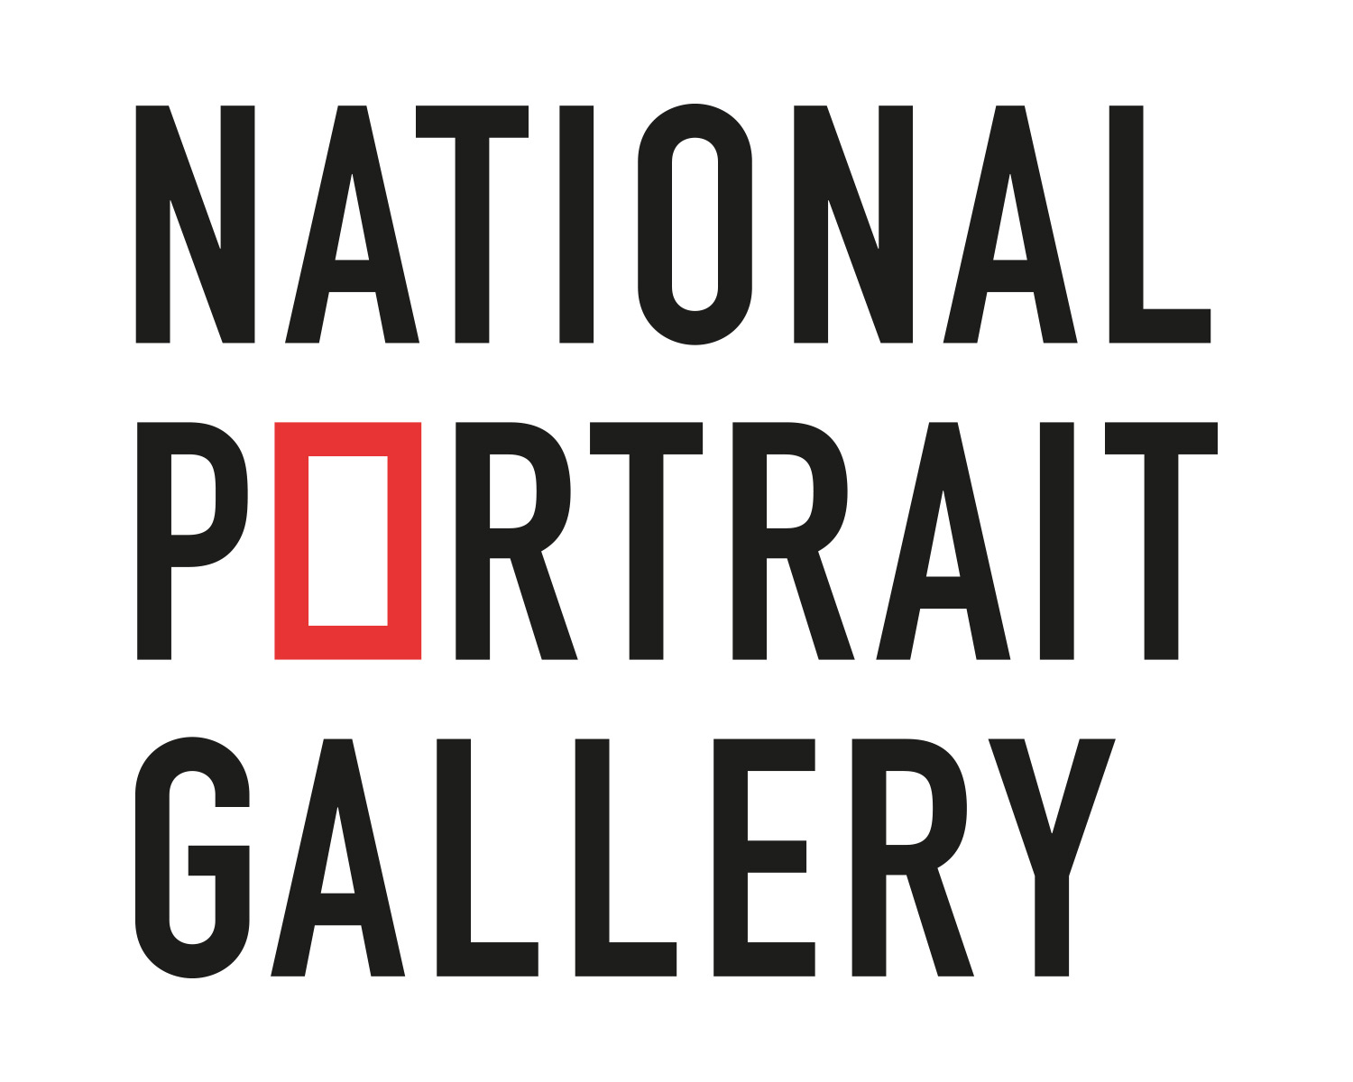

Meeting Place Media Partners
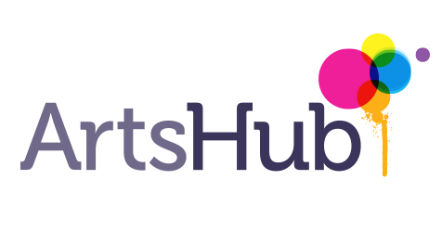

Support us

Become a Member
Arts Access Australia relies on the support of our Members to achieve our goals. By becoming a Member, you are actively sharing our vision for full and equal opportunity for cultural participation and contribution by all Australians.
You can join us as a Member via our website.

Donate
We are a small disability-led organisation who is fiercely committed to championing accessibility in the arts for all Australians. By donating, you can help us create real and lasting change for artists and arts-workers with disability.
You can donate to AAA via our website.

