

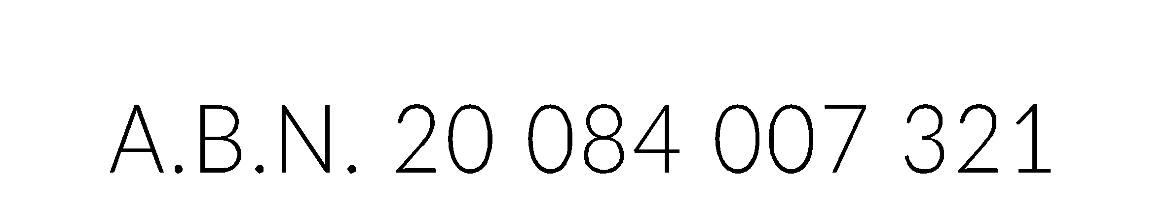

NOTICE OF ARTS ACCESS AUSTRALIA EXTRAORDINARY GENERAL MEETING

An Extraordinary General Meeting of members of Arts Access Australia (Company) will be held as follows:

**Date Monday 14 October 2024**

**Time 1.00pm Australian Eastern Daylight Time**

**Place Members are to attend, participate in and vote at the meeting, online or by phone, via the Zoom communications platform.**

Members are asked to indicate their intention to attend the meeting by 4:00 pm AEDT, Friday 11 October 2024, by AEDTemailing [board@artsaccessaustralia.org](mailto:board@artsaccessaustralia.org).

Please advise of any access requirements when confirming your attendance at the meeting.

**REGISTRATION IS REQUIRED TO ATTEND THE MEETING.**

Meeting access information will only be sent prior to the meeting start time to people who have registered to attend the meeting by the registration deadline. Information about the Zoom communications platform, including free registration, is available at <https://zoom.us/>.

All current members (ie Original Member representative, Ordinary Member or Life Member) of Arts Access Arts can attend. If you are unable to attend the meeting you are requested to appoint a proxy to vote on your behalf by completing the Proxy Voting form. If you need another copy of the proxy form, send an email to [board@artsaccessaustralia.org](mailto:board@artsaccessaustralia.org) to request one.

BUSINESS OF THE MEETING

1. Procedural matters

1.1. Quorum

1.2. Acknowledgement of Country

1.3. Apologies

2. Meeting Business

2.1. Update from AAA Board Chair

2.2 Statement of AAA financial position

2.2 To consider and, if thought fit, pass the following resolution: “To approve the deregistration of Arts Access Australia as an Australian Company Limited by Guarantee.”

*Meeting will recess to count votes cast*

2.3 Announcement of outcome of voting

2.4 Progress following outcome of voting

3. Other Business

3.1. To transact any other business which may legally be brought before the meeting

4. Meeting Close

IMPORTANT NOTE:

All Members (Original Members representative, Ordinary Members and Life Member) or their appointed proxy, are requested to attend this meeting and vote. If you are eligible to vote but can not attend the meeting it is important for the company to receive your completed and properly signed proxy form (together with any power of attorney or other authority under which it is signed (or a certified copy) by 4:00 PM AEDT on Friday 11 October 2024.

Martin Sawtell, AAA Chair  
22 September 2024

FREQUENTLY ASKED QUESTIONS

WHY IS AAA HAVING THIS MEETING?

The directors of AAA believe that the company does not have the funds to continue completing its purpose. The directors believe the AAA should close before it is unable to pay its debts. A meeting of the members of the company must have agreed to the close. This is called deregistration.

ARE YOU ENTITLED TO ATTEND AND VOTE?

Every Original Member, financial Ordinary Member, and Life Member of the company as at 4:00 PM AEDT on Friday 11 October 2024 is entitled to attend and vote at the Extraordinary General Meeting,

An Original Member organisation must appoint an organisation representative (or a proxy) in order to be able to exercise the entitlement to vote at the meeting.

WHAT IF YOU CAN’T ATTEND THE MEETING?

Any Member who cannot attend the meeting may appoint another person who is attending the meeting (called a “proxy”) to vote on your behalf at the meeting. See the “Proxies” section of this notice, below for details.

WHO ARE ORDINARY MEMBERS?

Every Member, including Life Members, who is not an “Original Member” or an honorary Life Member is an “Ordinary Member".

The Original Members (set out in clause 2.1(a) of the Constitution) are:

* Access Arts (CPL)
* Accessible Arts NSW
* Incite Arts
* Arts Access Darwin
* Arts Access Victoria
* DADAA
* Access2Arts

WHAT IS A PROXY?

A Proxy is when you nominate another person to attend the meeting and/or vote on your behalf. If you are entitled to attend and vote at the meeting (see “Are you entitled to vote?” above), you can appoint a proxy to attend and vote on your behalf. Your proxy does not need to be a member of the Company.

HOW DOES A PROXY WORK?

1. You direct your named proxy how to vote on an item of business. If your proxy does vote, they may only do so in accordance with your direction.
2. If you direct your named proxy to vote on an item and the proxy either does not attend the meeting the Chair of the meeting is automatically taken to be your proxy for the purposes of that vote and must vote as your named proxy was directed.
3. If the Chair of the meeting is (or becomes) your proxy and you have directed how your proxy is to vote, the Chair must vote as directed.
4. If you do not give any directions, your proxy may vote or not vote (abstain) as the proxy wishes.
5. A proxy is not entitled to speak or vote for you if you are present at the meeting.
6. You can lodge a completed proxy form by email to [board@artsaccessaustralia.org](mailto:board@artsaccessaustralia.org)
7. AAA must receive your completed and properly signed proxy form (together with any power of attorney or other authority under which it is signed (or a certified copy) by the Company by 4:00 PM AEDT on Friday 11 October 2024.
8. If you require an additional proxy form, please contact AAA by email at [board@artsaccessaustralia.org](mailto:board@artsaccessaustralia.org).