

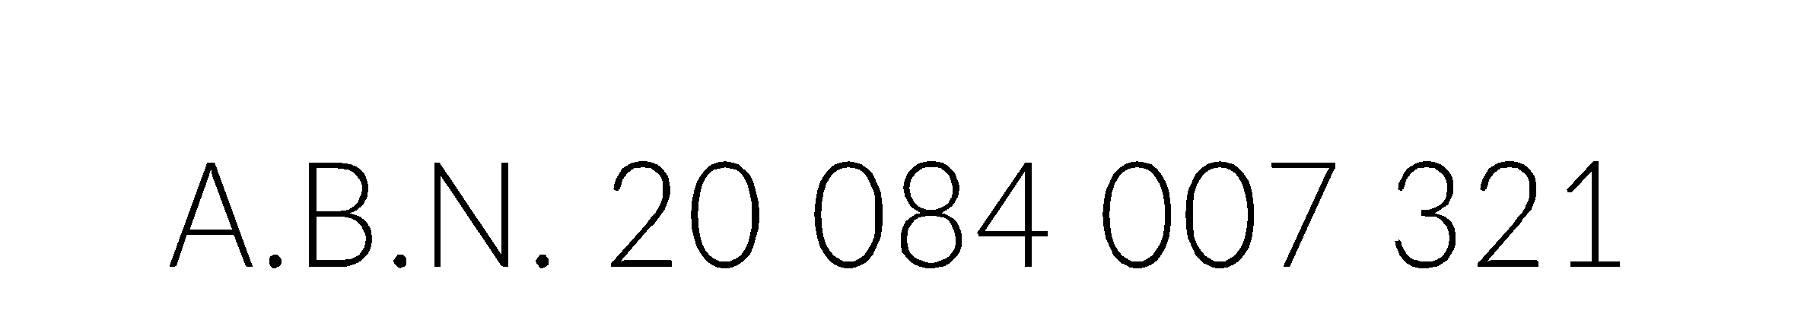

PROXY FORM FOR ARTS ACCESS AUSTRALIA  
EXTRAORDINARY GENERAL MEETING

Date Monday 14 October 2024

Time 1.00pm Australian Eastern Daylight Time

Place Members are invited to attend, participate in, and vote at the meeting online or by phone, via the Zoom communications platform.

APPOINTMENT OF PROXY

I ................................................................................................................................................   
(please print name)

of ................................................................................................................................................   
(please print your address)

being a member of Arts Access Australia and entitled to attend and vote at the Extraordinary General Meeting, appoint the following person as my proxy to vote on my behalf in accordance with the following directions (or if no directions are given, as the proxy sees fit) at the Extraordinary General Meeting of Arts Access Australia to be held on Monday 14 May 2024, and at any adjournment of that meeting:

Mark only **one** of the following two options:

**▢** I give my proxy to the Chair of the meeting

OR

**▢** I give my proxy to the member named below:

....................................................................................................................... Name of Proxy

........................................................................................................................ Address of proxy

And agree that if my named proxy does not attend the meeting, the Chair of the meeting.

You can lodge a proxy form by email to [board@artsaccessaustralia.org](mailto:board@artsaccessaustralia.org)

The Company must receive your completed and properly signed proxy form (together with any power of attorney or other authority under which it is signed (or a certified copy) by the Company by 4:00 PM AEDT on Friday 11 October 2024.

**Complete directions to your proxy on the next page.**

DIRECTIONS TO YOUR PROXY

If you do not direct your proxy how to vote, your proxy may vote as the proxy thinks fit or abstain from voting. If you mark the “Abstain” box, you are directing your proxy not to vote on your behalf, and your vote will not be counted when calculating the number of votes for a majority.

**I direct my proxy to vote as follows (the resolution numbers correspond to those in the notice of meeting):**

**▢ For**

**▢ Against**

**▢ Abstain**

CHAIRPERSON’S VOTING INTENTIONS

The chairperson of the meeting intends to vote undirected proxies **in favour of the resolution to support deregistration of Arts Access Australia LLC**.

SIGNING

This proxy form must be signed by the appointing member (or the member's attorney). A proxy given by a company must be signed by a duly authorised officer or attorney.

SIGNED:

**BY THE MEMBER**

................................................................................................................................................................. (Signature of Member OR duly authorised officer of the Member)

................................................................................................................................................................. (Please print name)

................................................................................................................................................................. (Date

OR

**BY THE MEMBER’S DULY APPOINTED ATTORNEY** (PLEASE ATTACH A COPY OF THE POWER OF ATTORNEY)

................................................................................................................................................................. (Signature of Member’s attorney)

................................................................................................................................................................. Pplease print name)

.................................................................................................................................................................

(Date)

WHO WARRANTS THAT THE APPOINTMENT IS VALID AND NO NOTICE HAS BEEN RECEIVED OF TERMINATION OF THE APPOINTMENT.